`
Vulcan Activity Tracker
Weekly Report

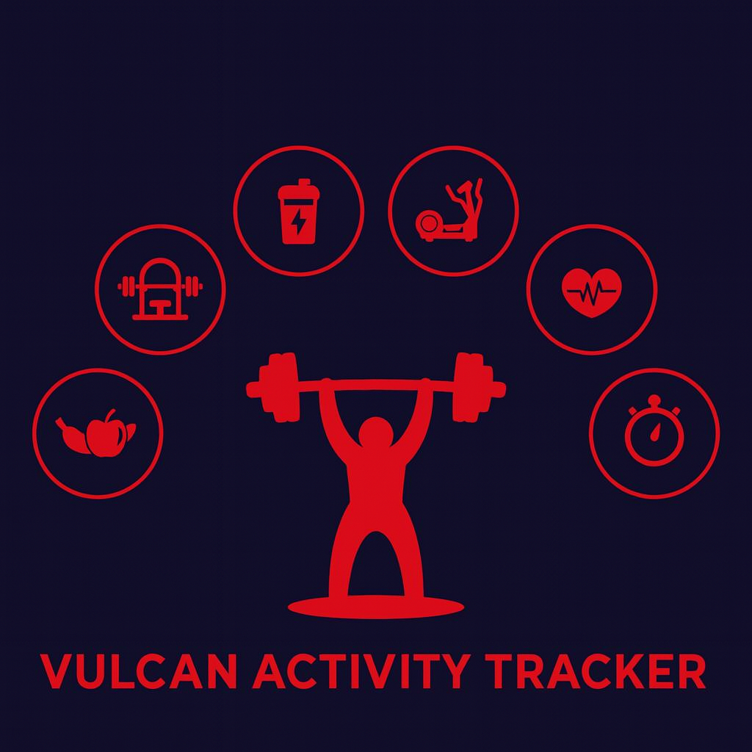

Week 7
Team Members:
Margo Bonal
John Gerega
Luke Ruffing

Professor: Dr. Weifeng Chen

Course: CMSC-4920-Senior Project II
School: Pennsylvania Western University

Table of Contents

Project: Vulcan Activity Tracker 2
Goals Accomplished: 2
Challenges Faced: 2
Solutions: 2
Team Progress: 2
Gantt Chart: 2
Week 8 Plan: 2
Member Contribution: 3

Project: Vulcan Activity Tracker

Goals Accomplished:

Challenges Faced:
(Number aligns with its solution below)

Solutions:

Team Progress:

Gantt Chart:
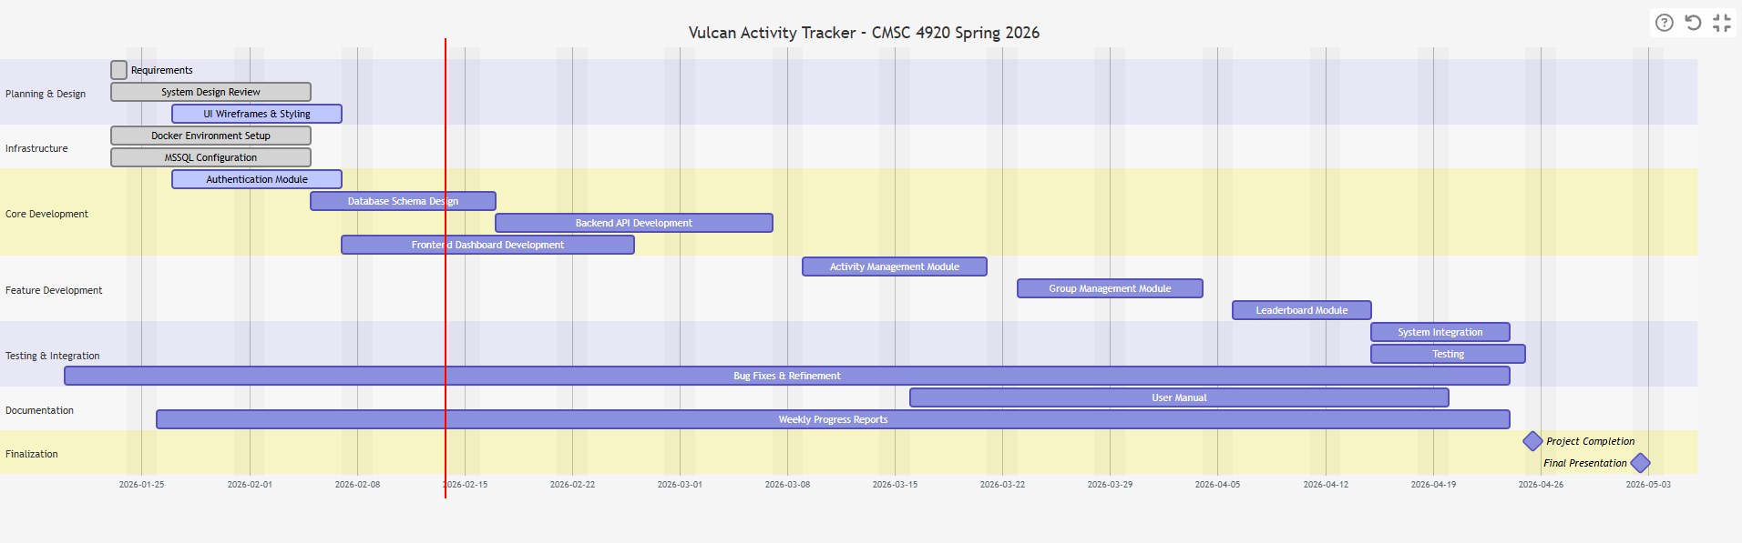

Week 8 Plan:

Member Contribution:

Team Members
Margo Bonal: | - Team meetings, Week 7 Report & Slides
John Gerega: | - Team meetings, Week 7 Report & Slides
Luke Ruffing: | - Team meeting, Week 7 Report & Slides,

